

71 Eaton Crescent, Taunton TA2 7UE
{prop_price_text}

A mid terrace two bedroomed property located in a popular residential cul-de-sac situated within convenient access to Taunton train station and local amenities. The house, although in need of some sprucing up internally, is offered with no onward chain and an early viewing is highly recommended.

Tenure: Freehold / Energy Rating: TBC / Council Tax Band: B

Eaton Crescent is located just off of Priorswood Road and forms a small cul-de-sac of similar properties alongside its neighbour, Compton Close. Built in the early 90's, this property offers sensible two bedroomed accommodation in the form of a entrance hall, kitchen to the front, and a sitting/dining room to the back and on the first floor, two bedrooms and a bathroom. There is also numerous cupboards around the house and the property has gas central heating and some double glazing. There is off street parking to the front and also an enclosed rear garden, mainly laid to lawn with a shed.

NO ONWARD CHAIN
EXCELLENT FIRST TIME BUY OR RENTAL INVESTMENT
SOME REFURBISHMENT REQUIRED
CUL-DE-SAC POSITION
CLOSE TO TAUNTON TRAIN STATION
CLOSE TO AMENITIES
GAS CENTRAL HEATING
DOUBLE GLAZING
EARLY VIEWING ADVISED

Entrance Hall

Kitchen 10' 5'' x 6' 5'' (3.17m x 1.95m)

Sitting Room 13' 4'' x 13' 0'' (4.06m x 3.96m) Double doors opening to the rear garden.

First Floor Landing

Bedroom 1 10' 7'' x 9' 7'' (3.22m x 2.92m) Plus two wardrobe recesses and an over-stairs cupboard containing the gas central heating boiler.

Bedroom 2 11' 3'' x 7' 10'' (3.43m x 2.39m)

Bathroom 7' 11'' x 4' 11'' (2.41m x 1.50m)

Outside There is off street parking to the front and an enclosed rear garden with a shed.

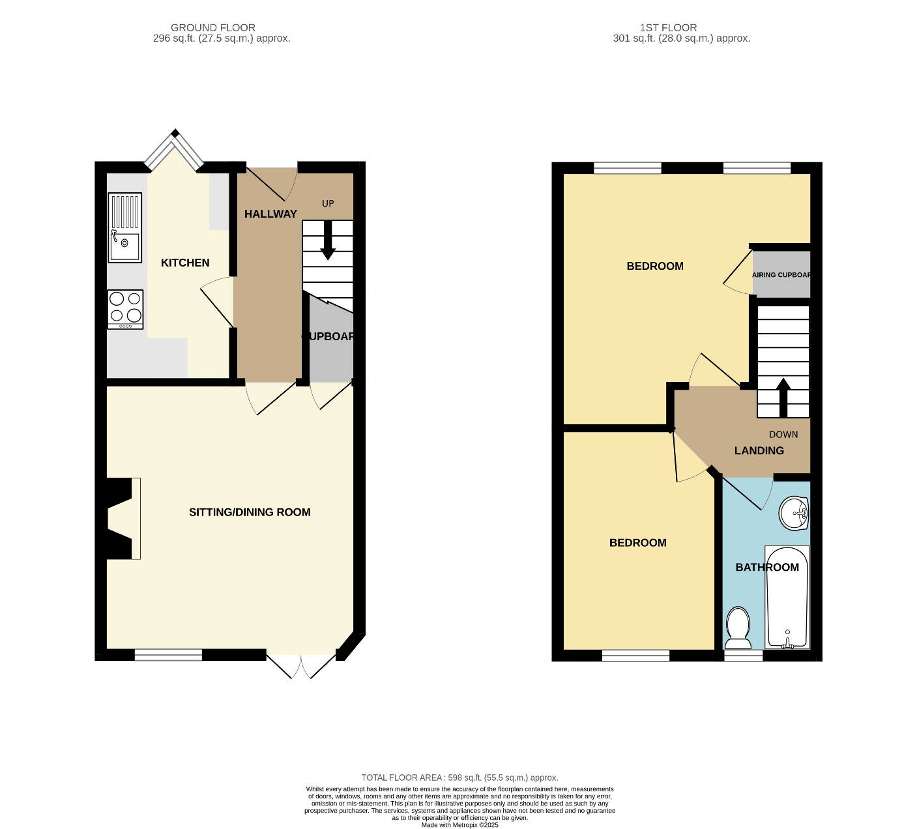
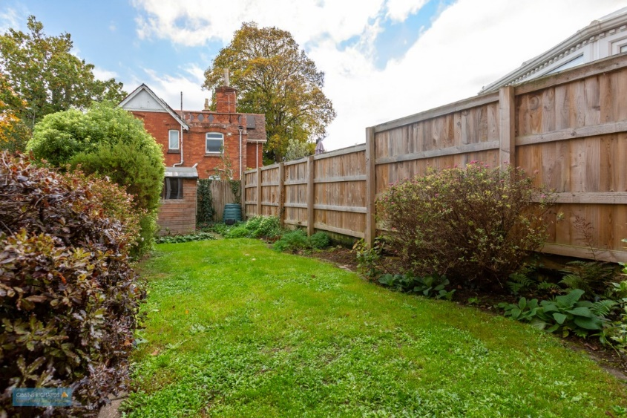

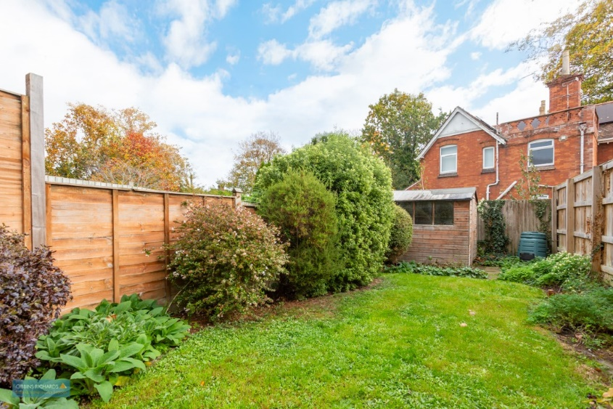

We routinely refer potential sellers and purchasers to a selection of recommended conveyancing firms – both local and national. It is their decision whether to use those services. In making that decision, it should be known that we receive a payment benefit of not more than £200 per transaction.
We routinely refer potential sellers and purchasers to Mortgage Advice Bureau (MAB) for mortgage and protection advice. It’s their decision whether to use those services. In making that decision, it should be known that we receive a payment benefit of not more than £250 per case.
Once an offer is accepted by our client, an Administration Fee of £40 + VAT (£48) per buyer will be required in order for us to process the necessary checks relating to our compliance and Anti-Money Laundering obligations. This is a non-refundable payment and cannot be returned should a purchase cease to continue. It can be paid via a card machine, or via BACS transfer.

50 High Street, Taunton, Somerset TA1 3PR Tel: 01823 332828
Email: tn@gibbinsrichards.co.uk Web: www.gibbinsrichards.co.uk

